Documention

Real-Time Network Topology Change Alerting System

Introduction

The Real-Time Network Topology Change Alerting System is designed to continuously monitor network devices and detect topology changes in real time. The system collects CDP/LLDP neighbor information, compares the current network topology with a predefined baseline, and identifies new devices, removed devices, or changed connections. It classifies each change based on its risk level and immediately alerts network administrators about high-risk events. This improves network security, reduces manual monitoring efforts, and helps maintain a reliable and stable network infrastructure.

Problem Description

Build a real-time monitoring system that:
(1) continuously polls CDP/LLDP neighbor tables across all switches, (2) maintains a baseline 'expected' topology graph,
(3) detects new devices, removed devices, or changed connections in near real-time,
(4) classifies changes by risk level (new switch in a server rack = high risk, expected laptop reconnect = low risk),
(5) sends immediate alerts for high-risk topology changes with full context.

Phase 1 – Problem Analysis & Tool Design

- Analyze the problem statement and identify project objectives.
- Define functional and non-functional requirements.
- Identify target users and system use cases.
- Prepare the Software Requirement Specification (SRS).
- Select the technology stack and development tools.
- Design the system architecture and workflow.
- Prepare the data flow and module design.

Software Requirements Specification(SRS)

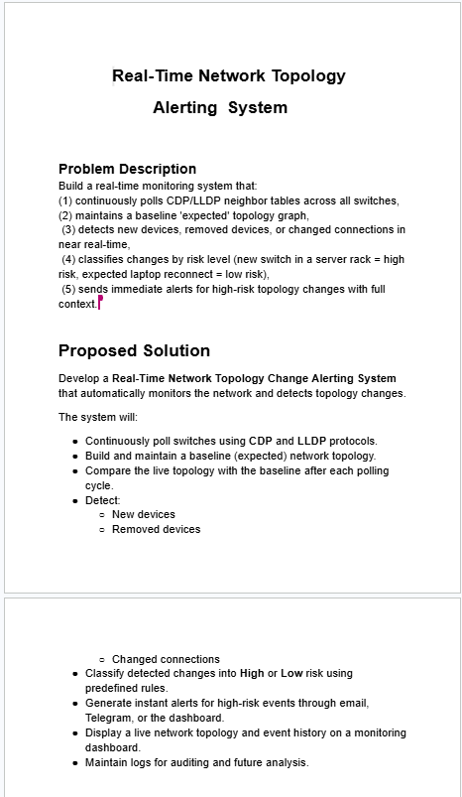
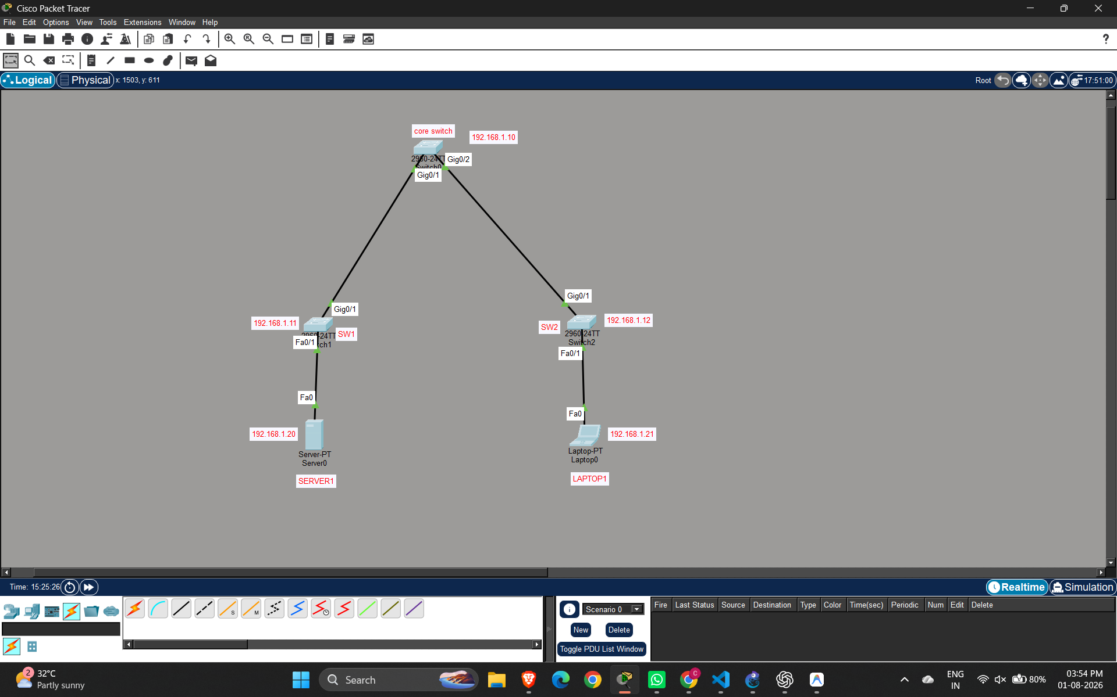

In the first phase, we analyzed the problem statement and identified the project objectives. We gathered both functional and non-functional requirements, identified the target users, and prepared the Software Requirement Specification (SRS). We also selected the technology stack and designed the system architecture, workflow, and module structure to create a strong foundation for the project.

Phase 2 – Workflow Design & Basic Frontend

- Design the complete system workflow.
- Create UI wireframes and page layouts.
- Develop the basic frontend using HTML, CSS, and JavaScript.
- Design the dashboard and navigation.
- Create the topology upload interface.
- Prepare placeholders for visualization and alerts.
- Organize the frontend for backend integration.

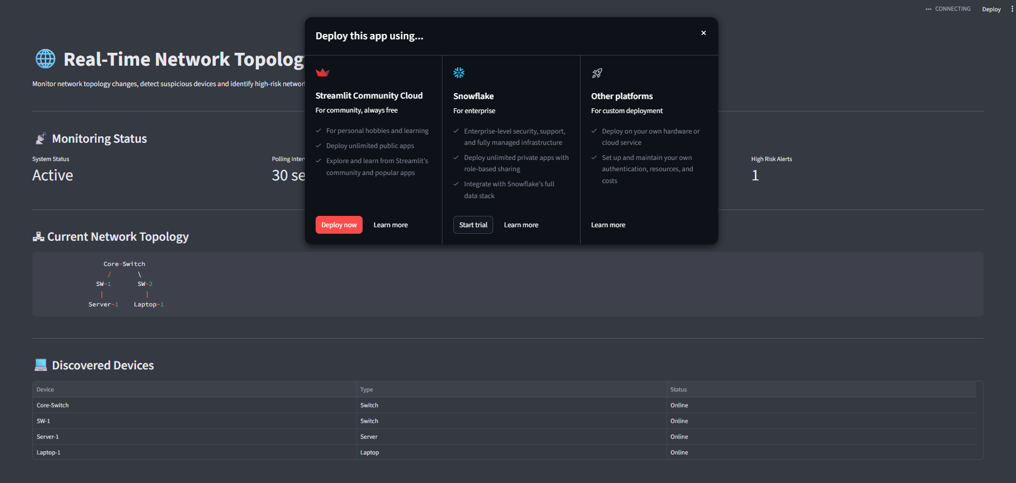

In the second phase, we designed the complete system workflow and created UI wireframes for the application. We developed the basic frontend using HTML, CSS, and JavaScript, designed the dashboard and navigation, created the topology upload interface, and prepared sections for network visualization and alert notifications. The frontend was also organized for easy backend integration.

Phase 3 – Complete Frontend Development

- Implement dashboard and navigation pages.
- Complete the topology upload module.
- Design alert and notification panels.
- Implement network visualization interface.
- Create history and status pages.
- Validate UI functionality and responsiveness.
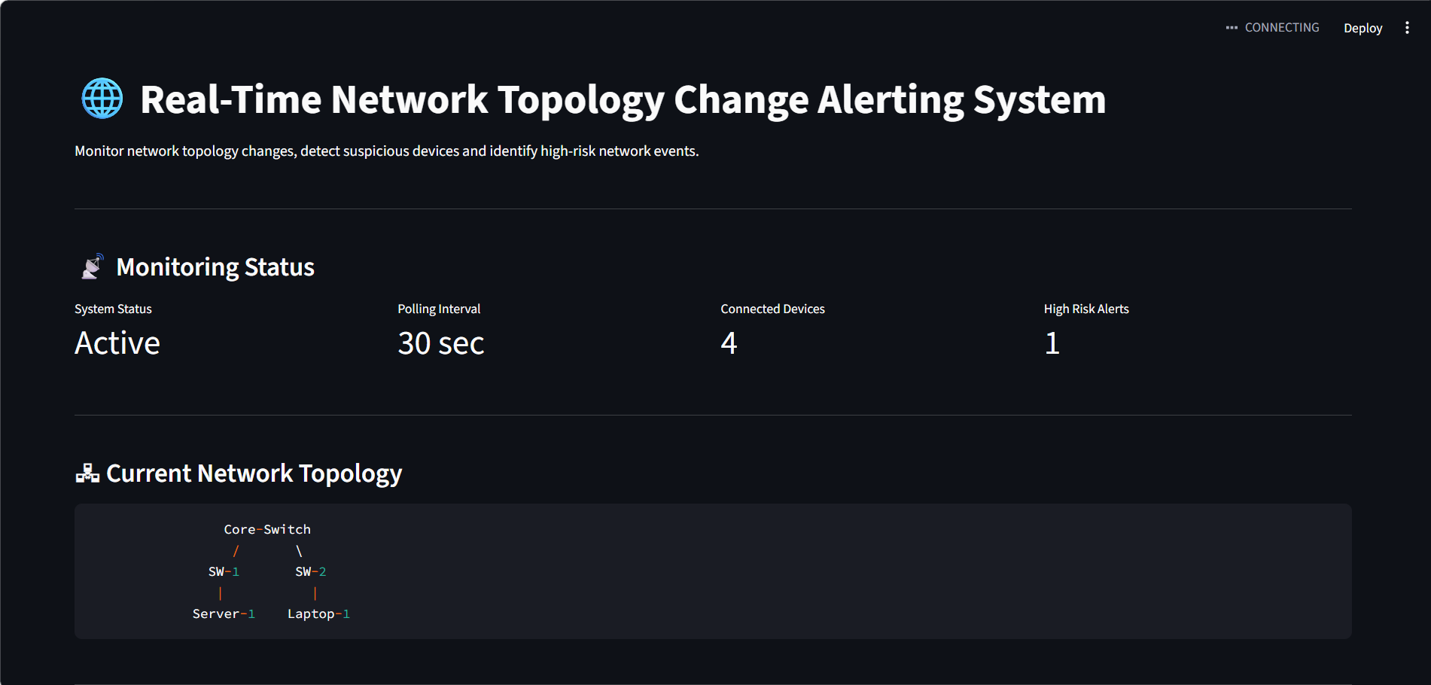
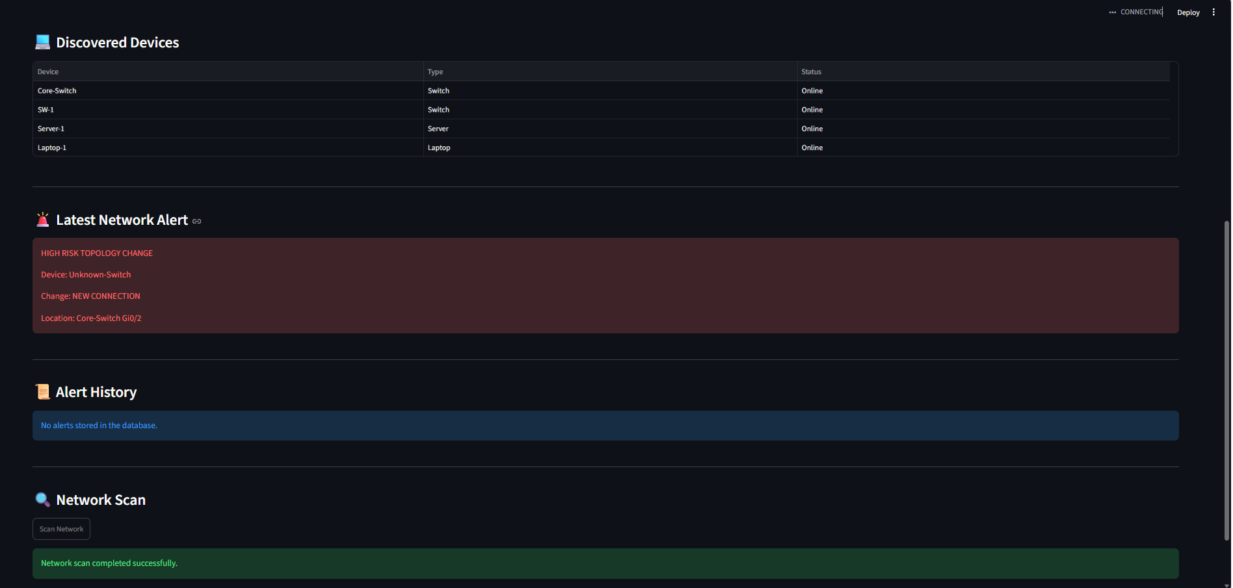

In the third phase, we completed the frontend development by implementing the dashboard, navigation, topology upload module, alert panels, network visualization interface, and history pages. We also tested the user interface for functionality and responsiveness to ensure it is ready for backend integration.

Phase 4 – Deployment and System Integration
- Deploy the React frontend application to a cloud hosting platform (Vercel).
- Deploy the Node.js backend server and configure REST APIs and Socket.IO services.
- Configure and deploy the Python network discovery module for real-time topology monitoring.
- Set up the production database (SQLite/PostgreSQL) and establish backend connectivity.
- Integrate the frontend, backend, Python services, and database into a unified system.
- Perform end-to-end testing to validate real-time topology detection, alert generation, and dashboard functionality.
- Monitor the deployed application, resolve deployment issues, and prepare the system for final project demonstration.

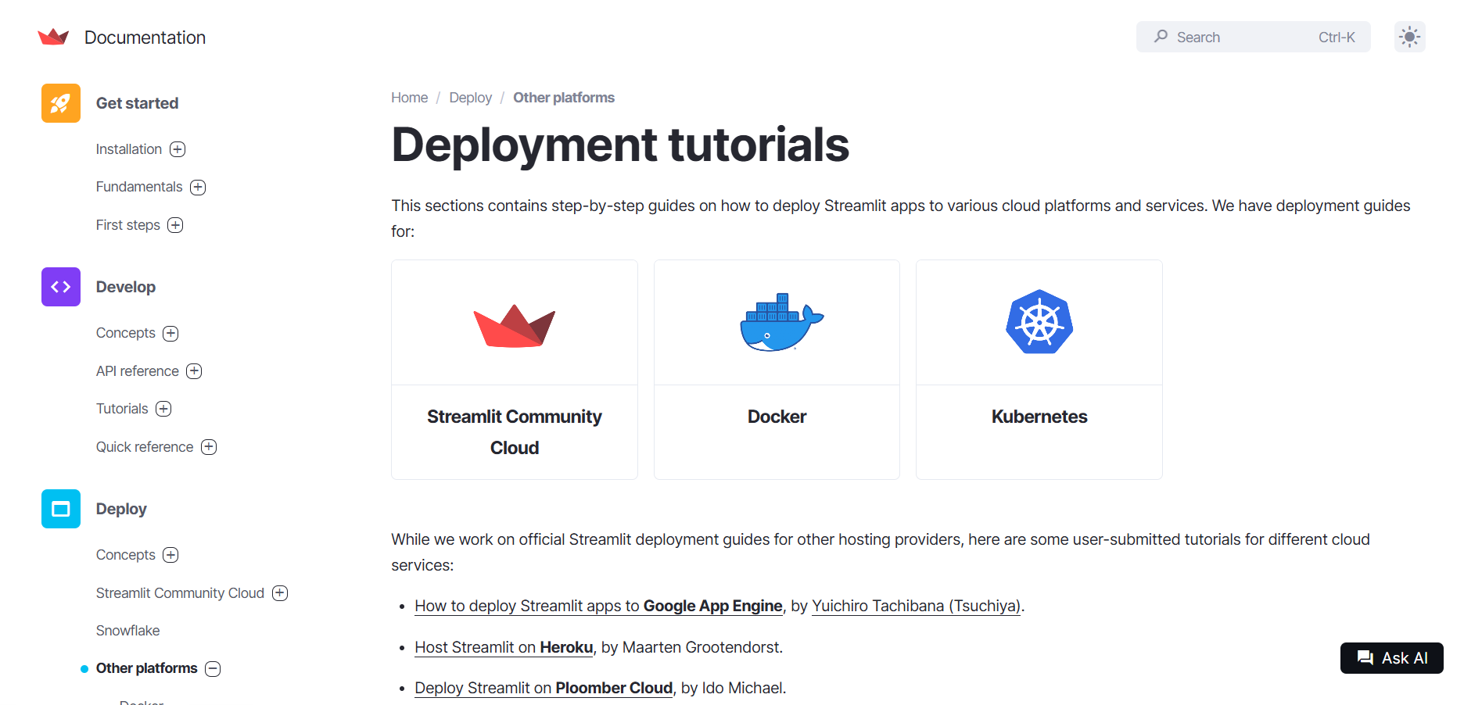

Conclusion
The Real-Time Network Topology Change Alerting System continuously monitors the network, detects topology changes in real time, and generates alerts based on the risk level. It helps network administrators quickly identify unauthorized devices, removed connections, and network changes, improving network security, reliability, and efficient management.

